**CENWP-OD-B05 June 2023**

**MEMORANDUM FOR THE RECORD**

**SUBJECT: 22BON025 MFR AFF Salmonid Mortality**

On 05 June, Columbia River Inter-Tribal Fish Commission (CRITFC) Biologists notified Bonneville Project Biologists of one lamprey mortality found on the valve 15 trash rack in the Adult Fish Facility (AFF). The fish was scanned for PIT tags, inspected, and returned to the river.

1. Species – Pacific Lamprey (*Entosphenus tridentatus)*
2. Origin – Unknown
3. Length – 71.12 cm
4. Marks and tags – None
5. Marks and Injuries found on carcass – Head contusion, bleeding from mouth
6. Cause and Time of Death – Unknown
7. Future and Preventative Measures – None

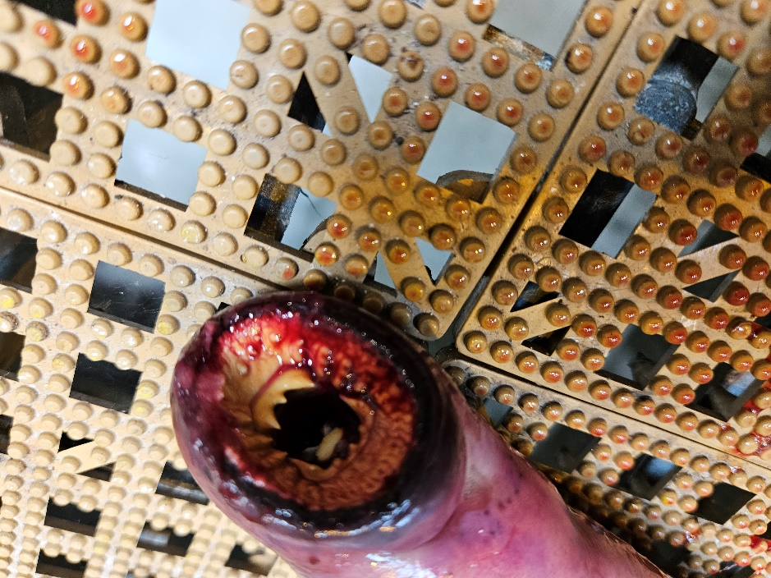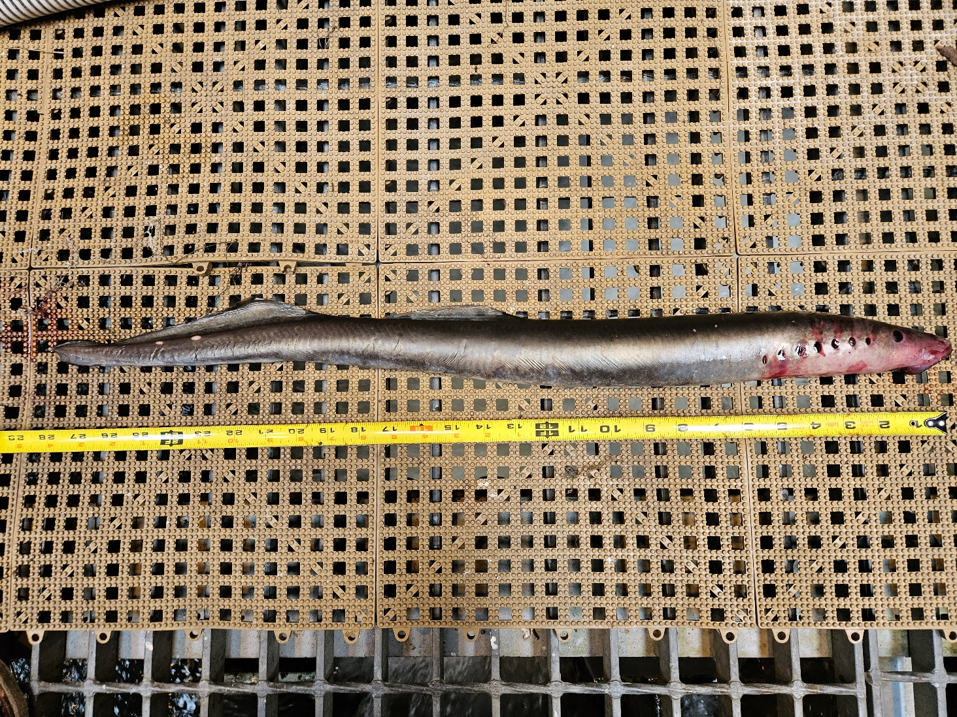

Sincerely,

Bonneville Project Fisheries